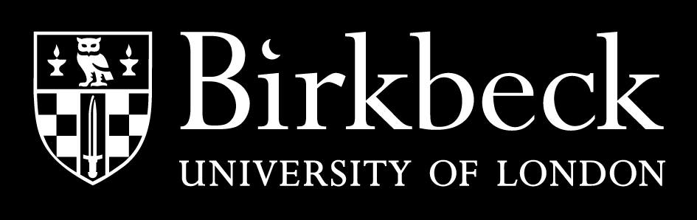

**COURSEWORK COVER SHEET**

|  |
| --- |
| **Date**: 12/07/2024 |
| **Student number**: 13921034 |
| **Programme of Study**: social research and psychosocial studies |
| **Module**: Masterclass in social research |
| **Assessment**: Blog Post |
| **Word count (including all footnotes, references and appendices)**: 1002 |
| **Disability and dyslexia support**: Do you have an Individual Student Support Agreement with the Birkbeck Disability Office that is relevant to this coursework?  **No** *(Please delete as appropriate)* |
| **Plagiarism statement**:  Coursework is monitored for plagiarism and if detected may result in disciplinary action. In submitting this coursework, I hereby confirm that I have read Birkbeck's plagiarism guidelines and taken the online tutorial on avoiding plagiarism and on this basis declare that this coursework is free from plagiarism.   * Plagiarism guidelines: <https://www.bbk.ac.uk/student-services/exams/plagiarism-guidelines> * Plagiarism tutorial: <https://www.bbk.ac.uk/student-services/learning-development/preparing-for-study> (scroll down to Citations and Referencing) |

**Unheard Voices: Using Oral Histories to Unearth Somalia's Forgotten Genocide**

The word genocide carries a lot of pain and just by definition alone it resonates most people with empathy and a call for justice. This sadly is not just a word read and heard by a large population of the world. The people of Somalia were subject to the torment and destruction of communities and civilisations during the struggles of the civil war atrocities (Figure 1).

Image from <https://www.bbc.co.uk/news/in-pictures-26351649>

The collapse of the Somalia as a state began and the African region became a country well known for its political abuses which were riddled with violence and a cycle of monopolising power Ingiriis, M. H. (2016). This was fuelled by the violence between clans[1], a staple for Somalis socio-political identity. The destruction and displacement of civilians based on interclan violence majored by the president of the time who deployed unimaginable war crimes on the Issaq clan.

As being one of the largest clan groups in the northern region of, Hargeisa, Somalia. A range of sources have estimated the death toll of civilians of this clan being upwards of [200,00.](https://web.archive.org/web/20240513044957/https:/www.aljazeera.com/features/2014/2/6/investigating-genocide-in-somaliland) In an research project on the genocidal events that occurred in Hargeisa, it was reported that the destruction that was caused [killed over forty thousands](https://web.archive.org/web/20240513044957/https:/www.aljazeera.com/features/2014/2/6/investigating-genocide-in-somaliland) of innocent people lives were taken, others were forced to flee.

We live in a world that other people’s experiences and lifestyles are plastered across social media platform. A short quirky video on TikTok that details the creator’s real life experience a window of opportunity to its viewers to engage with and give their thoughts on. A daily task with a routine step by step tutorial so much accessibility worldwide nation-wide people across the entire globe able to laugh, argue sympathise with, but what about those who have been left out of this digitalised engagement, whose stories have not been shared or engaged with?

Oral histories quite literally are what is sounds like, a space where history is explored through the voice of the actors involved. The voices of the past. Now in a traditional sense history was often recorded through documents and figures. It shifts focus from assumptions of what was recorded a area of inquiry into actual experiences. Hearing form the people involved in a drastic politically hot moment can provide a fresh insight, painting a picture that can be entirely different from what was known. A room for the unknown, hidden, silenced, ignored. This is not to say it is a new method, it was used historically and continues to progress as an excellent method. Where memories are a strength to universalise and sharing of experiences.

**The question that burns is how can this translate to social research?**

The process of research is to create knowledge or develop it further adding to the intricates of questions that challenge society or widen the understanding of experiences. As oral histories have been a part of several disciplines from anthropology, sociology, and ethnic studies and more. This vast variety positions the method to work amazingly for the people of the past as the core idea of the method being to understand a unique take subject to the individual or group. An insight of the minds and hearing the voice of those who are involved will surely develop a level of detail that can lead to a rich exploration on past events. The creation of oral histories can be cultivated using traditional qualitative approaches of interview style questions allowing room for the individual or even groups of people to express themselves and their story.

The questions that the oral historian asks can be structured openly and develop depending on the answers that are given. These types of questions open the room for free expression of the persons history whilst also widening the perspective of the researcher. This freedom of expression deepening from the realms of understanding histories in an what I would call an intimate fashion. The intimacy of persons real life story, the emotions that are shared of what journey was embarked on in that moment. That memory that is shared now has a place to be acknowledged, explored, and interpreted in the context of research. If we take a moment to understand the importance of how this acknowledgement serves purpose for the communities of people who stories are untold, ignored or simply disregarded. A methodology that can be used not only by academics, but by individuals who aim to provide coverage to the voices of the people before them.

**An untold depiction of social change: The story of the UFFO group**

The demolition of the issaq clan has a remarkable story of retribution and freedom, that the Hargeisa group were all too familiar with in the case study of the groups of professionals and academics also known as the ‘UFFO’ a nickname which translates to [“the good smelling wind before the rain”](https://www.somtribune.com/2018/12/14/somaliland-punish-the-good-for-doing-good-the-uffo-saga/) a poetical saying made that so well describes their struggle for the greater peace they intended for their country. They were wrongfully convicted due and sentence to ranging prison sentences for speaking out against the governments heinous decisions that lead to them landing eight long years of solitary confinement and unimageable war crimes. This story deserves to be told, an oral historical insight of this groups tragedies but important turning point in the Somali political history. This can look like an interview conducted with a member of the uffo group, where they are given the opportunity to share in their own words what they experienced, their life story and what detrimental lasting impact they were left with as they embarked on the journey to such dramatic social and political change of the country.

1. Layered in all aspects of life, the **clan is both a tool for identification and a way of life**. Clans define the relationship between people and all actors in ... European Union Agency for Asylum (EUAA). (2023, December). Home Country Guidance Somalia 2023 1.2. The role of clans in Somalia [Website].